Software Requirements Specification

for

**Electronics Mart**

Version 1.0 approved

**Prepared by Mohit, Namit, Manish, Deepanshu, Pearl**

**NCU**

**02-02-2022**

Table of Contents

Table of Contents ii

Revision History ii

1. Introduction 1

1.1 Purpose 1

1.2 Document Conventions 1

1.3 Intended Audience and Reading Suggestions 1

1.4 Product Scope 1

1.5 References 1

2. Overall Description 2

2.1 Product Perspective 2

2.2 Product Functions 2

2.3 User Classes and Characteristics 2

2.4 Operating Environment 2

2.5 Design and Implementation Constraints 2

2.6 User Documentation 2

2.7 Assumptions and Dependencies 3

3. External Interface Requirements 3

3.1 User Interfaces 3

3.2 Hardware Interfaces 3

3.3 Software Interfaces 3

3.4 Communications Interfaces 3

4. System Features 4

4.1 System Feature 1 4

4.2 System Feature 2 (and so on) 4

5. Other Nonfunctional Requirements 4

5.1 Performance Requirements 4

5.2 Safety Requirements 5

5.3 Security Requirements 5

5.4 Software Quality Attributes 5

5.5 Business Rules 5

6. Other Requirements 5

Appendix A: Glossary 5

Appendix B: Analysis Models 5

Appendix C: To Be Determined List 6

# Introduction

## Purpose

Electronic Mart is a Web-Application whose requirements are mentioned in this document, this is first version of application. It is a User-Friendly E-commerce website it will enable customers to browse the products efficiently. The administration module will enable system administrators to manage products, orders and users.

## Document Conventions

* Entire document should be justified
* Convention for main title.
* Font Face: Arial
* Font Style: Bold
* Font Size: 32
* Convention for sub title.
* Font Face: Times
* Font Style: Bold
* Font Size: 18
* Convention for body.
* Font Face: Arial
* Font Style: Normal
* Font Size: 11

## Intended Audience and Reading Suggestions

|  |  |
| --- | --- |
| * Developers | * Project Managers |
| * Marketing Staff | * Testers |
| * Documentation Writers | * Users |

This SRS contains description, requirements, features of project. Suggested reading sequence is from description to different types of mentioned requirements and then features.

## Product Scope

* Secure registration & profile management facilities for customers with an additional functionality of 2-factor authentication.
* Adequate searching mechanism for easy & quick access to particular products.
* Creating a Shopping cart so that customers can shop 'n' no. of items and checkout finally with the entire shopping carts. Customers can add or delete items in the cart.
* Regular updates to registered customers through newsletter about Sales, Amazing Deals and New Arrivals.
* Showing the products with customer rating in each category.
* Maintaining database of customers with their interested category of products.
* Administrators are responsible for internal affairs like processing orders, updating order's status and managing products.
* Customers can give ratings & review for the product which they have purchased & used (or delivered to them).
* Adequate payment mechanism and gateway for all popular credit cards, cheques and other relevant payment options.

## References

* Mongo DB – <https://docs.mongodb.com/manual/tutorial/>
* NPM - <https://www.npmjs.com/>
* Heroku - <https://devcenter.heroku.com/articles/deploying-nodejs>
* Node JS - <https://nodejs.org/en/docs/>
* Express JS - <https://expressjs.com/>
* HTML5 – <https://www.w3schools.com/TAGS/default.ASP>
* CSS3 – <https://www.w3schools.com/cssref/>
* JAVA SCRIPT - <https://www.w3schools.com/jsref/default.asp>

# Overall Description

## Product Perspective

Electronic Mart is a Web-Application, it is a User-Friendly E-commerce website it will enable customers to browse the products efficiently. This website is intended to be a new, self-contained product and should depend on the availability of mongo cloud, Heroku servers. It should be able to run on any device which supports browser.

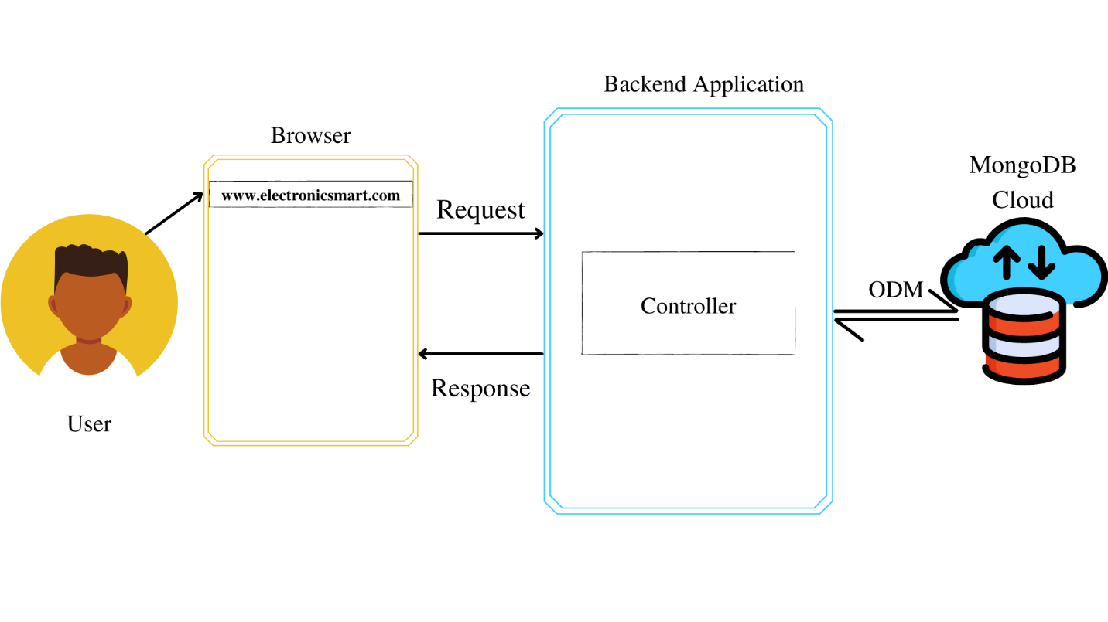

Fig. 2.1

*ODM – Object Data Manipulation

## Product Functions

* The main purpose of this project is to reduce manual work.
* Function:
* Customers can search products by category, name, ratings and price range.
* After successful login Customers can add & edit items in cart.
* Customers can also view the status of any previous orders & cancel any order that has not been shipped yet.
* Customers can modify personal profile information (such as name, phone No., email & other details) & can enable of disable Two-Factor Authentication for additional security.
* Admins can manage products, orders and users.

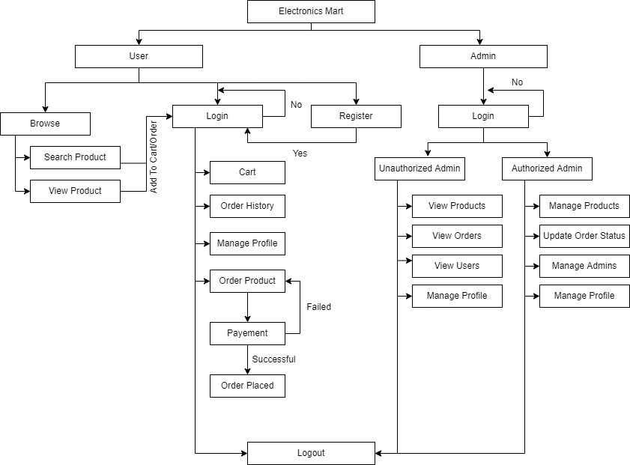

Fig. 2.2

## User Classes and Characteristics

* Customers should be able to search products, manage cart, order products, manage their profile.
* Admins have following management functionalities –
* Admin – view products, users, orders
* Authorized Admins – manage products, orders, users, admins.

## Operating Environment

The product will be operating in any device which supports browser functionality.

Electronics Mart is a website and shall operate in all famous browsers, for a model we are talking about Google Chrome, Microsoft Edge, Mozilla Firefox, etc.

Hardware configuration include necessary requirements to run a browser application in device.

To use website the device should be connected to internet.

## Design and Implementation Constraints

* Website application should be light weight & simple API.
* The database should be able to manage huge amount of data and should have flexible schema with sharding (basically horizontally scalable) so preferred database language is Mongo DB.
* Mongo atlas should be used for storing data on cloud having 10GB storage & 2GB RAM.
* Website should be built under Micro service Architecture.
* The programming language should support Distributed application with many nodes, asynchronous operations (basically I/O) and good in data centric processes.
* Programming language for backend – Node JS and framework – Express JS.
* Programming language for frontend – HTML 5, CSS3, Java Script.
* Project design should be modular with better readability.
* Communication protocols should be in XML documents encoded in UTF−8 and sent using HTTP or HTTPS.
* Security consideration are encryption of password in database, authentication for all users & admins for accessing pages which requires identification, authorization check for admins, two factor authentication check if enabled and secured account recovery options.
* Loading time should ne minimum and for that use AWS servers for deployment of project for best performance. With RAM 2GB, OS Windows 8 64-bit, Hard Disk size of 10GB.
* The application should be able to run on cross platform so CORS should be enabled.
* User & admins have different Front-End applications to perform actions

## User Documentation

The product will include user manual. The manual will include product overview, complete configuration of the software (such as Mongo DB server and other technologies used), technical details, backup procedure & contact information which will include email address. The product will be compatible in any browser and database will be created in Mongo DB.

## Assumptions and Dependencies

The assumptions are –

* The coding should be error free.
* Any Front-End request should not give Timeout error or should not have any Internal Server Error.
* The system should be user friendly so that it is easy to use for the users.
* The Electronics Mart is a 24X7 running website except the servers where application & database are deployed & stored goes down.
* User can access Electronics Mart from any device which supports web browser and an internet connection.
* User & admins have their correct usernames & passwords to enter into their online accounts & do actions.

The dependencies are –

* The Servers due to which the web application will run.
* The Payment process is dependent on the payment plugin while purchasing the product.
* On the basis of listing requirements & specifications the project will be develop & run.
* The admins, Client IT team should have proper understanding to the project.
* The Information of all users must be stored in a database that is accessible by Electronics Mart system.

# External Interface Requirements

## User Interfaces

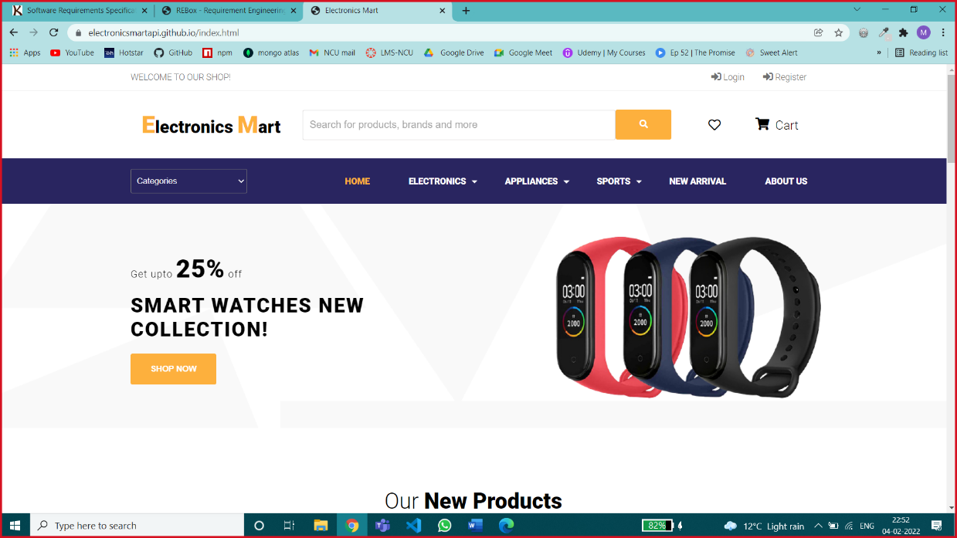

Home Page – Customers can view products on this page.

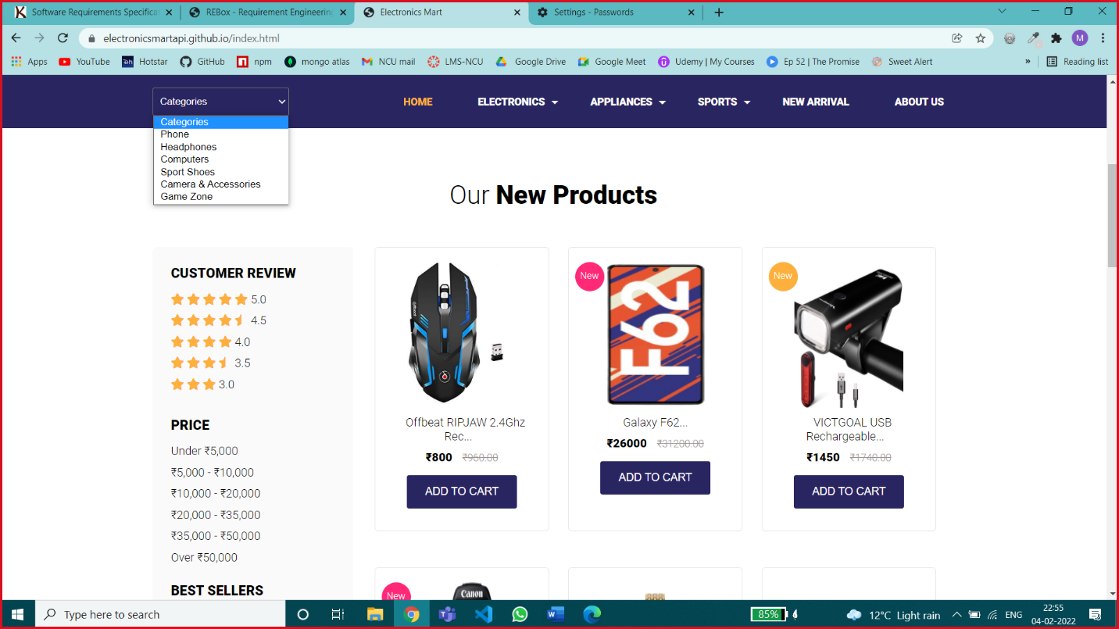

Different Options for Searching Products – Customer can search products by specific category, by Customer Review, by price range, by name.

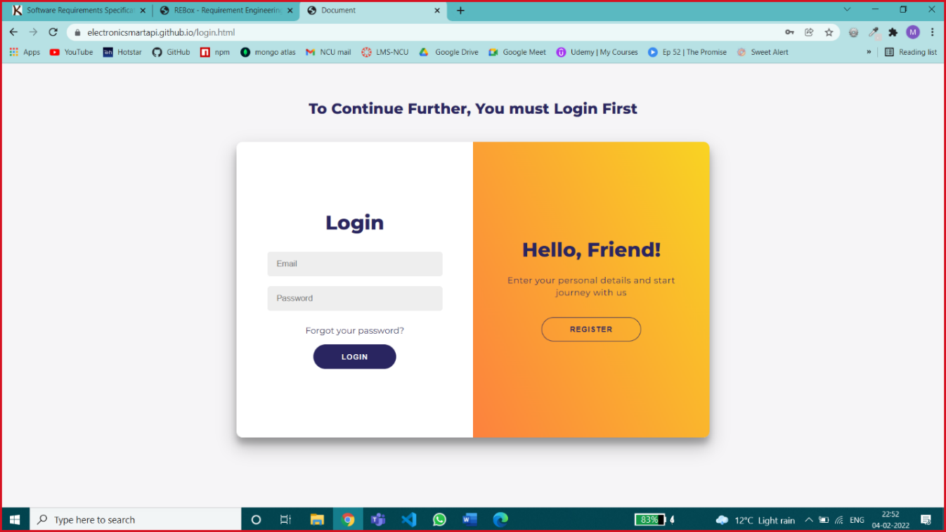

Login Page – Customer can login with correct E-mail Id & password or can create a new account by clicking on register button

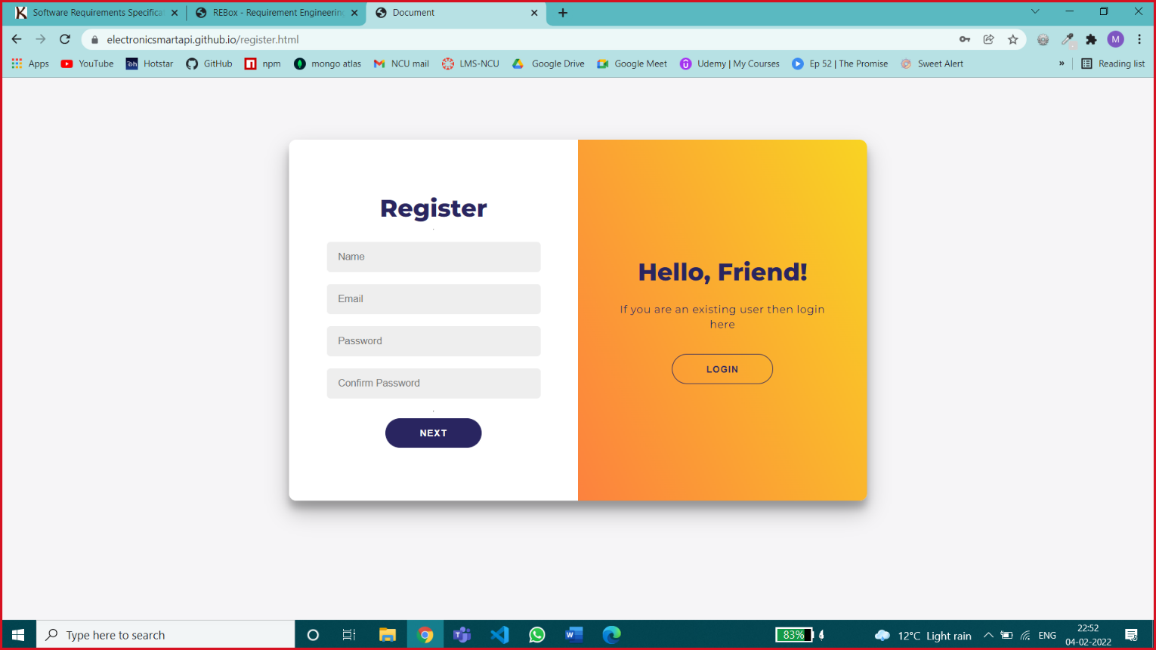

Registeration Page 1 – this page is accepting all primary & sensitive information like email id & password for creating new account, all fields are necessary.

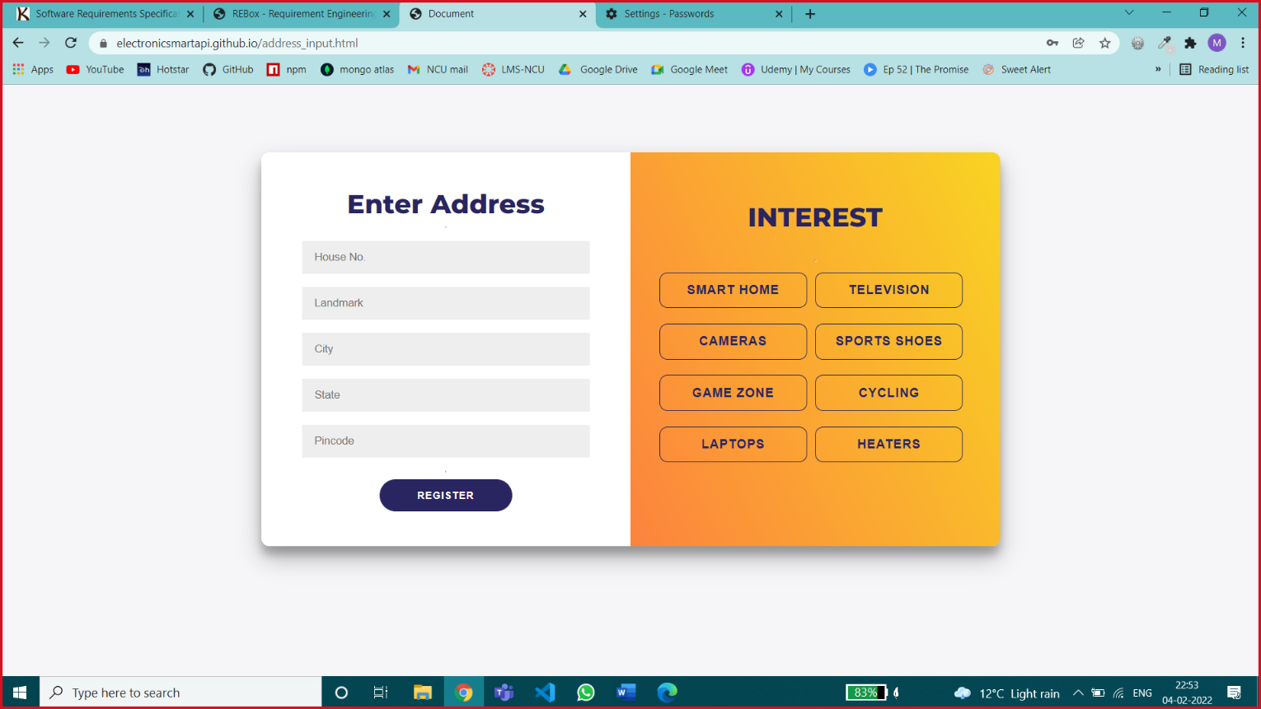

Registeration Page 2 – this page is accepting customer details like address & interested category of products by selecting popular categories & address is necessary, interest is an optional field.

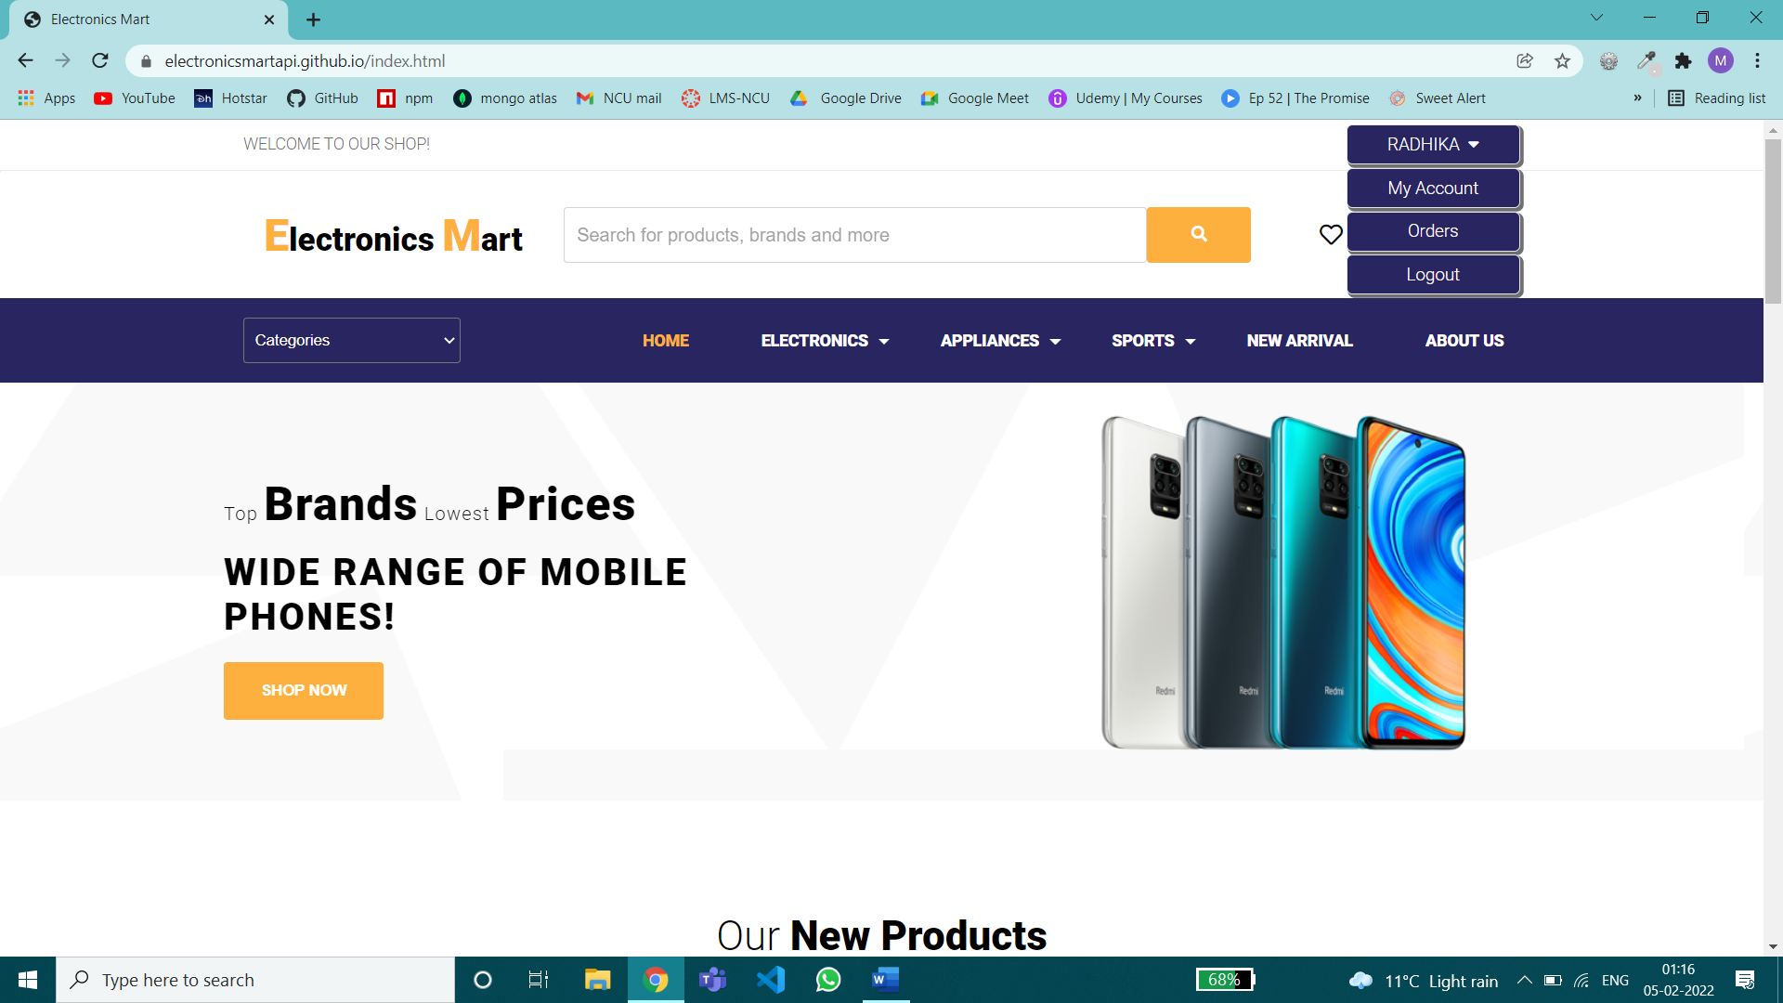

After Successful Login User will be redirected to home page for browsing products, add products to cart, order products & will be provided my account, my orders, logout feature on the top left.

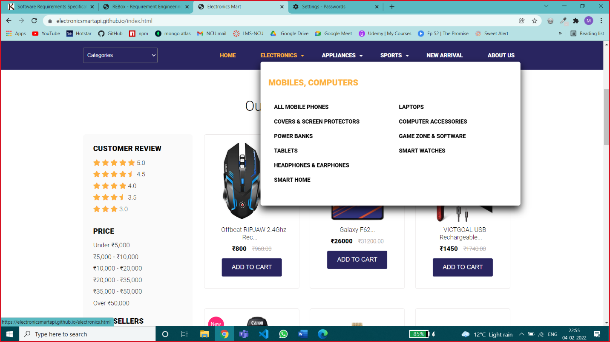

Sub-Category Dropdown Menu – In which major categories are divided into sub categories

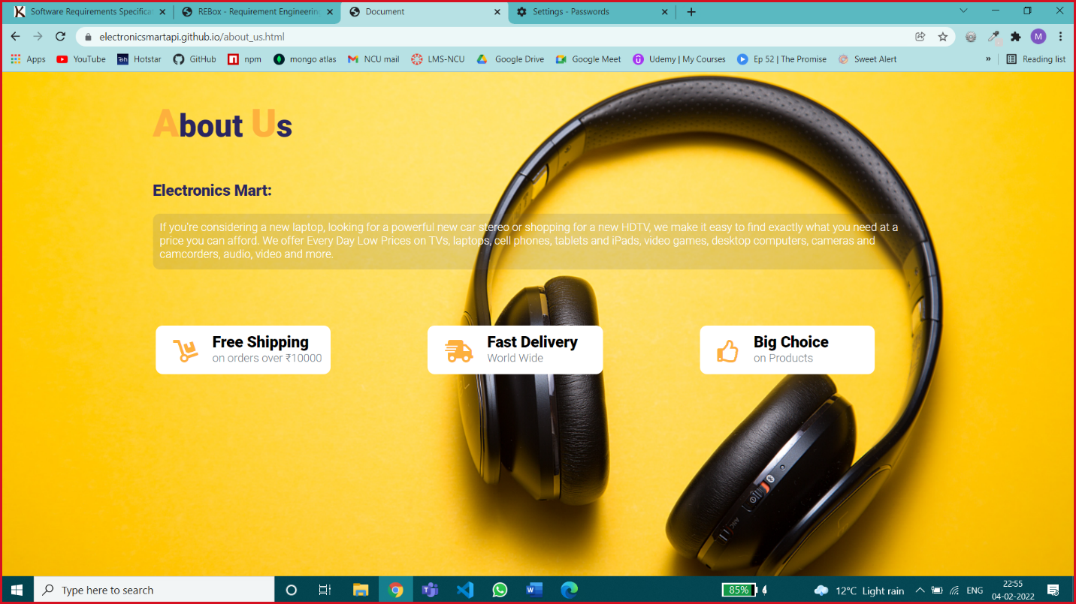

About Us Page – consist of basic information of website

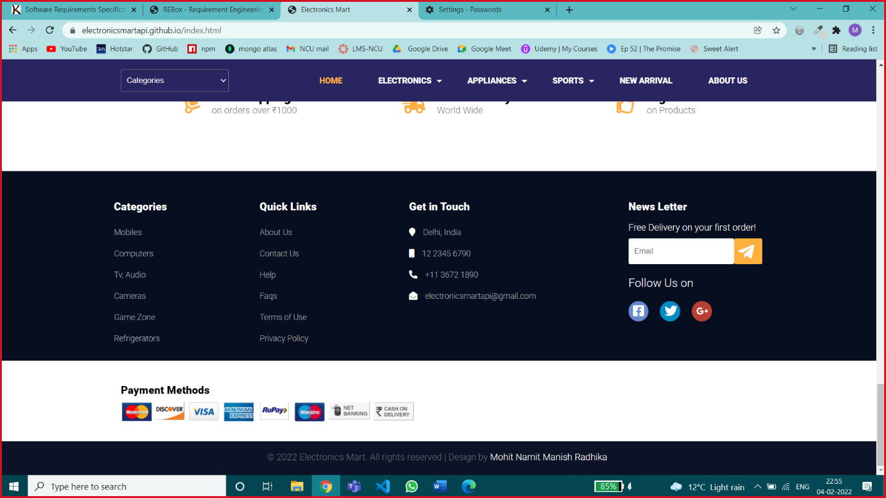

Footer of Website – News Letter service, Few other basic options.

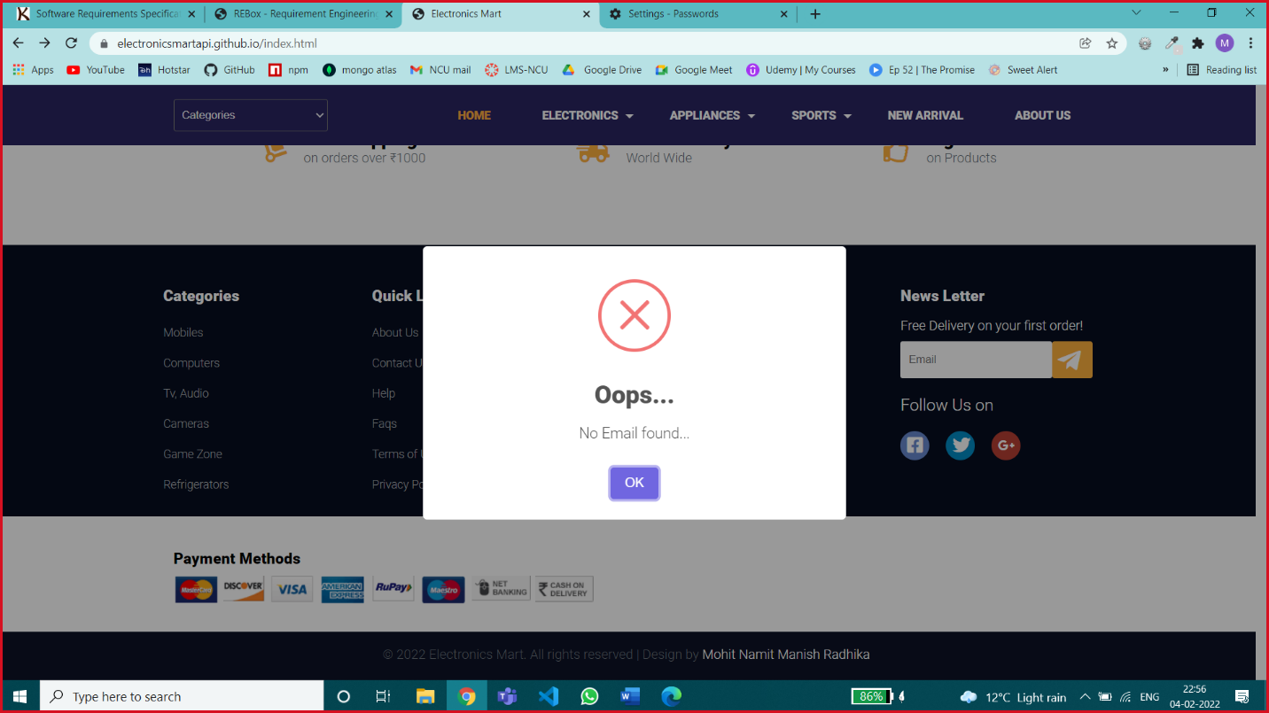

Error Message for any Invalid Input or for any Blank Input where field input is necessary.

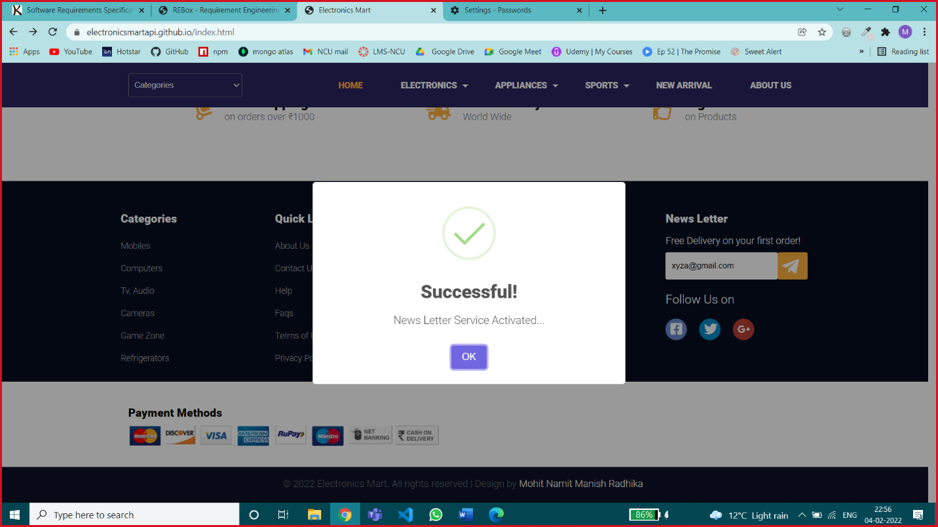

Success Message – for success Status

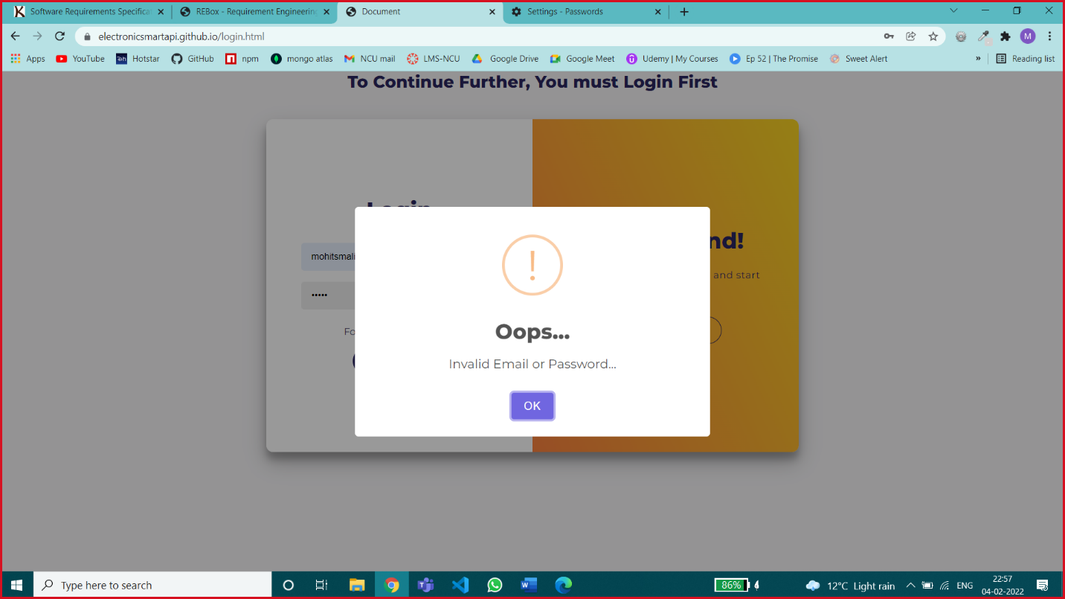

Error Message for Wrong Credentials

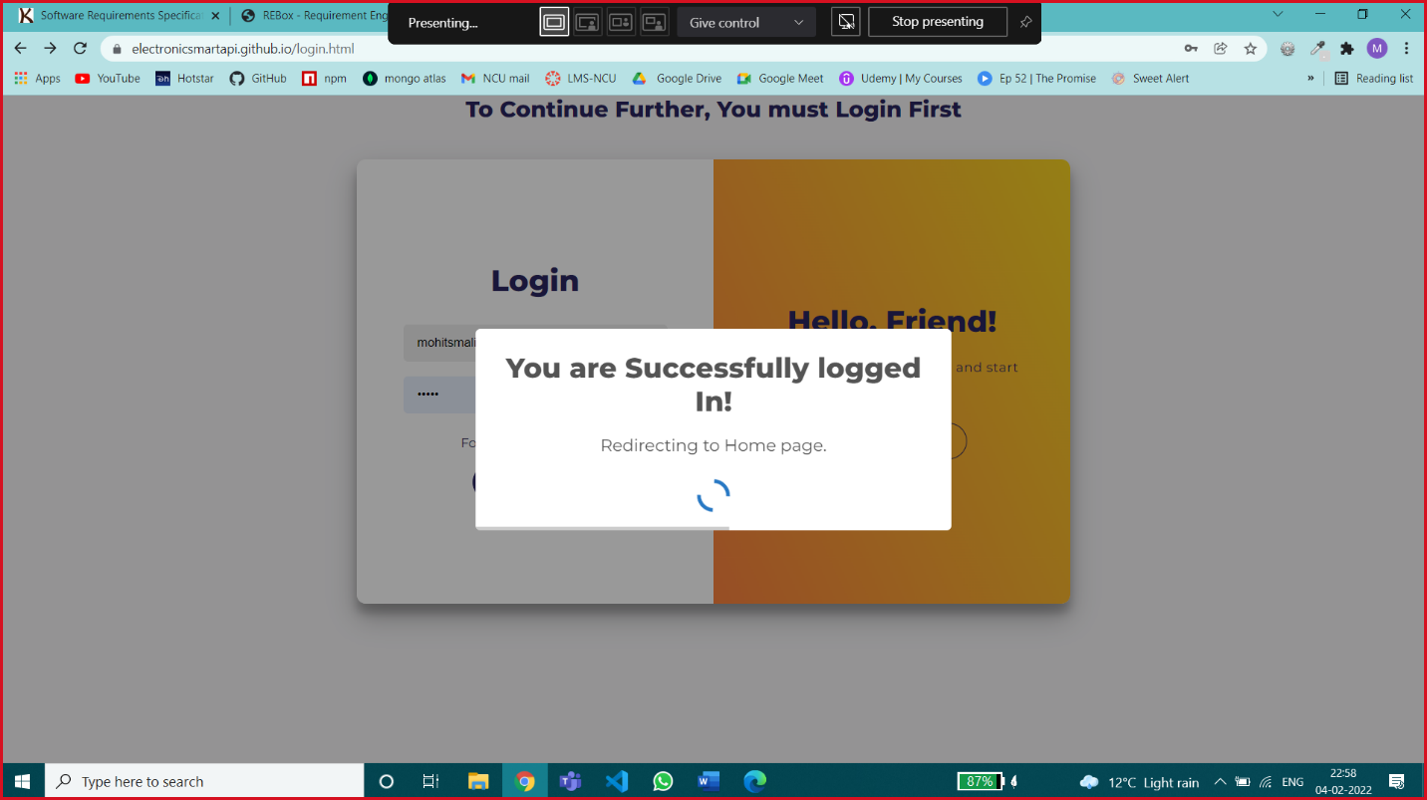

Loading Message

Screen Layouts Constraints –

Device height is not a screen layout constraint, if the height varies the content will be vertically scrollable

For particular device width ranges different website screen layouts are shown below.

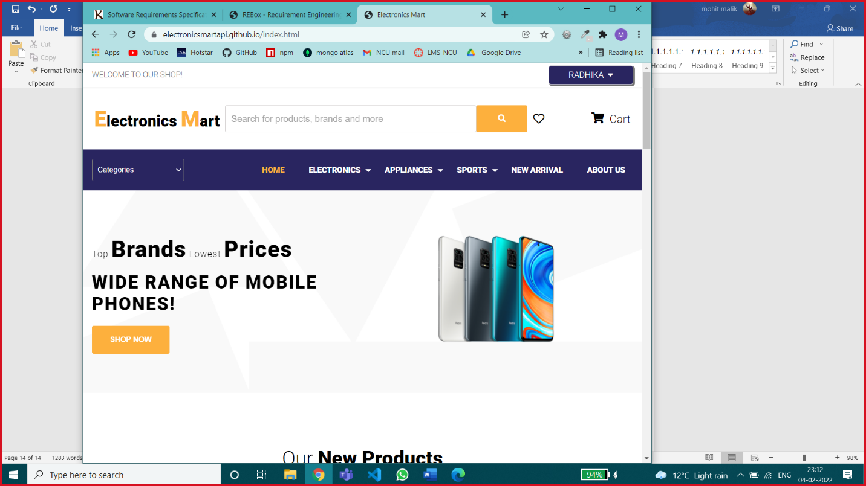

Screen width – greater than 992px

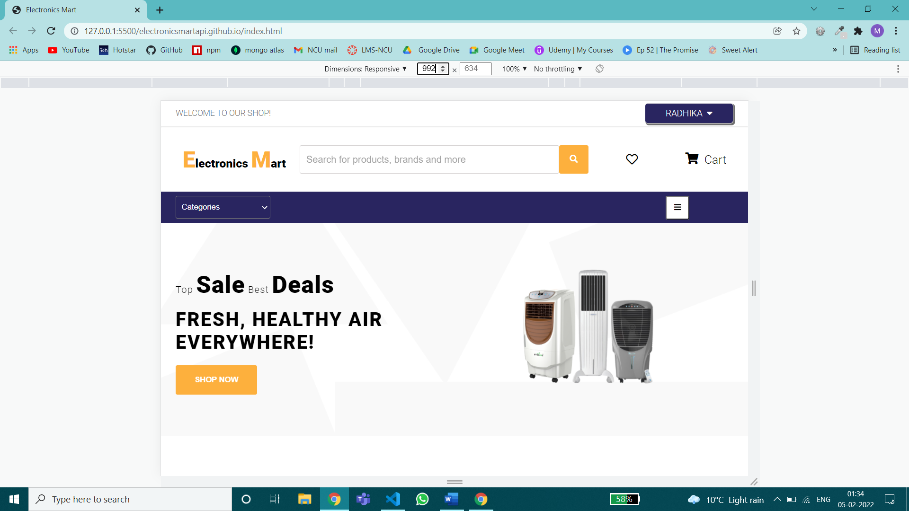

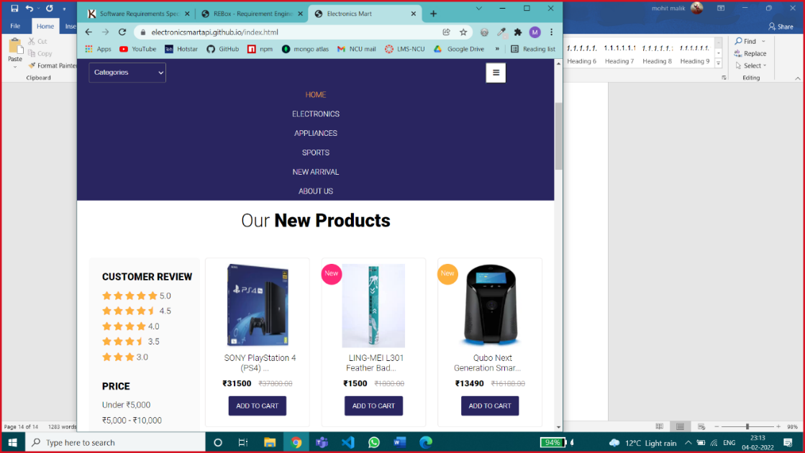

Screen Width between 992px & 768px

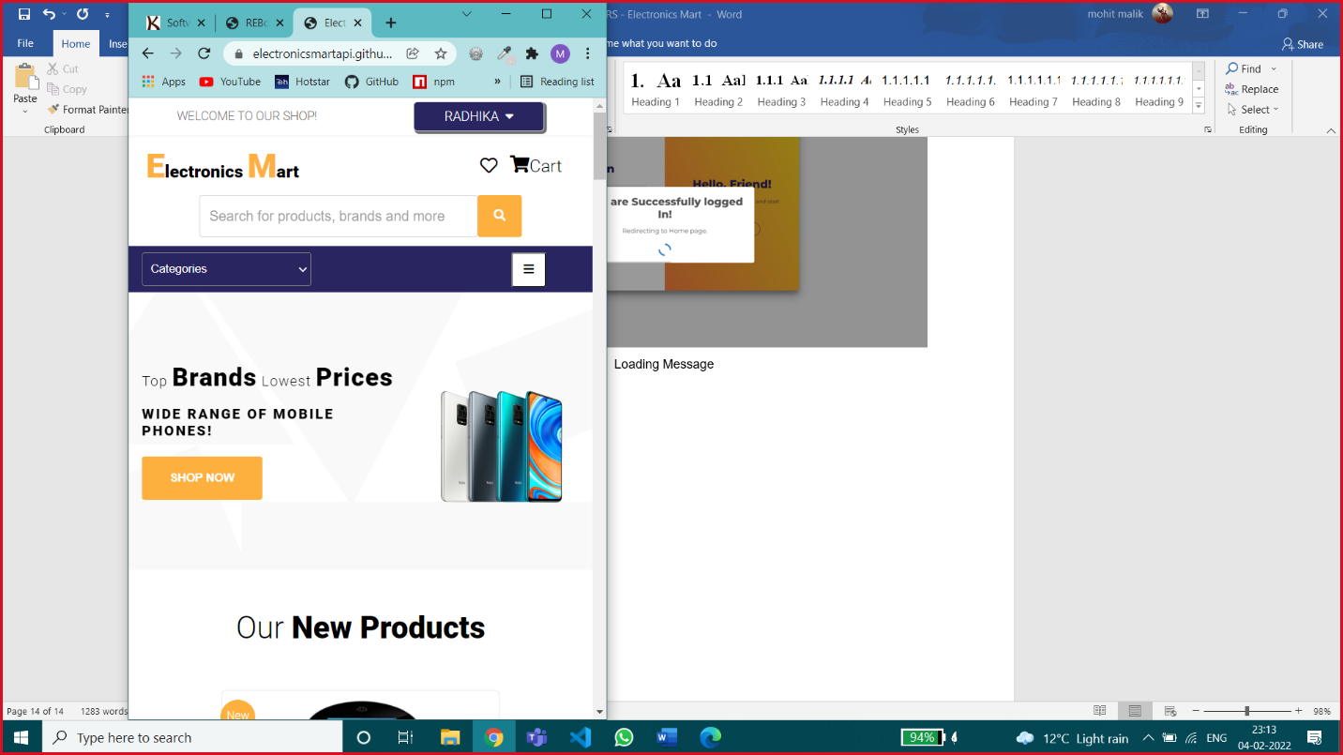 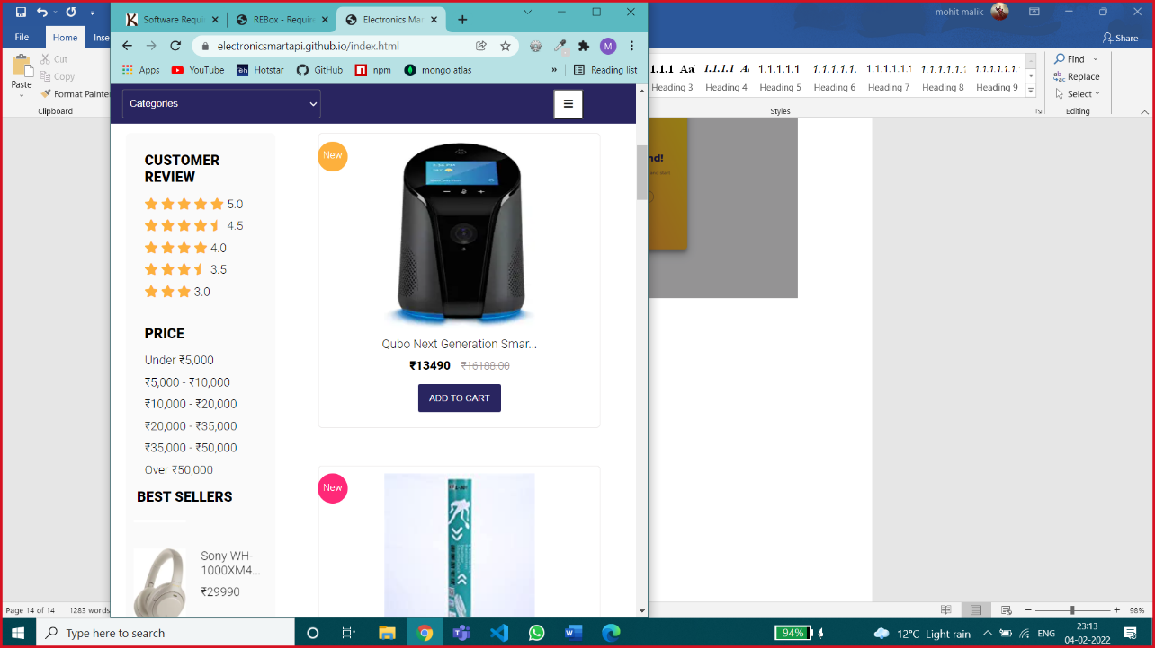

Screen width between 768px & 576px

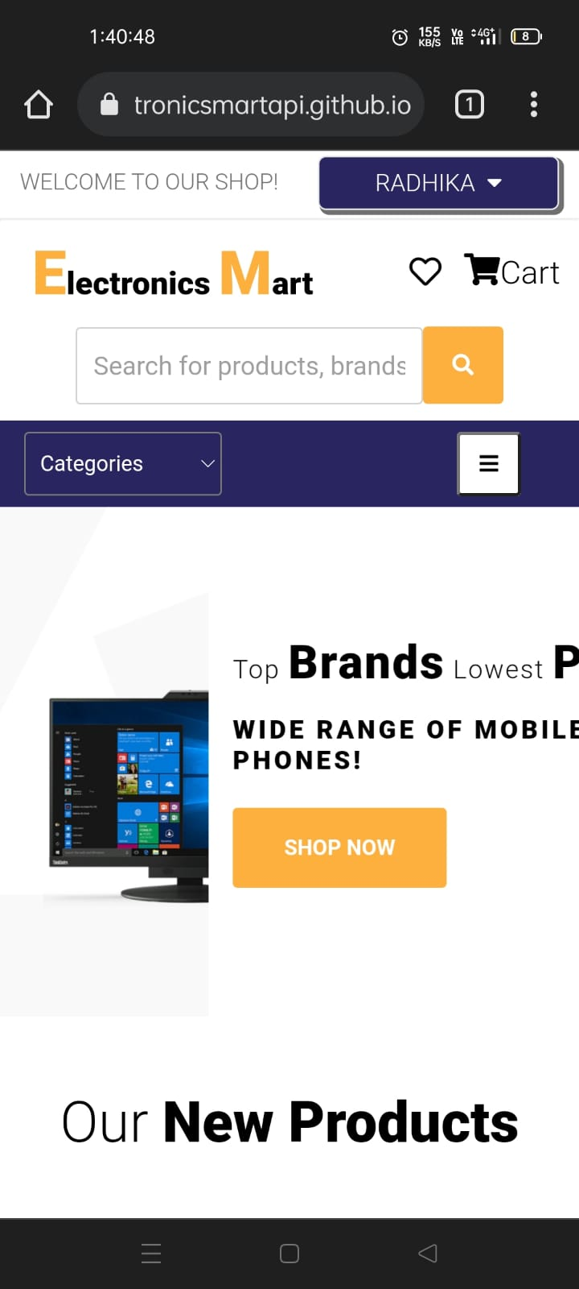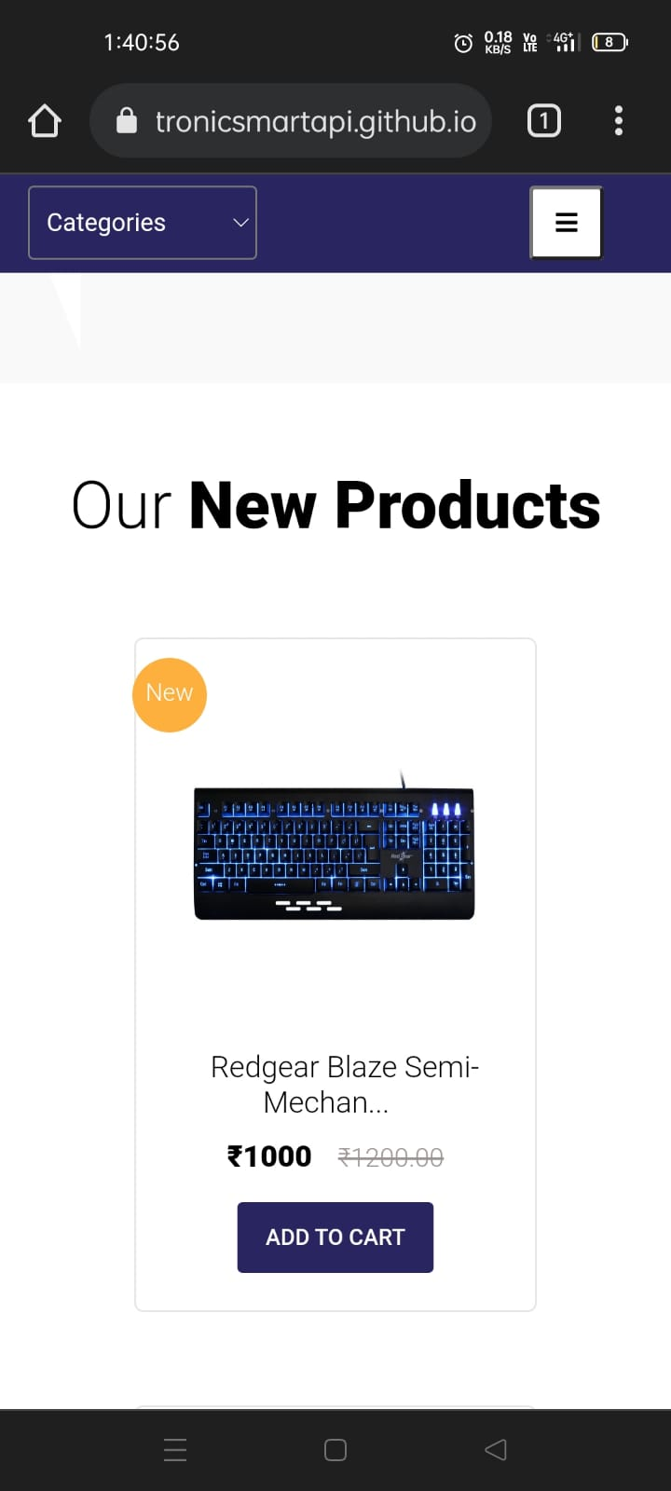

Screen width below 576px

## Hardware Interfaces

Any Hardware Device that supports the following Browsers will be able to run Electronics Mart –

Good Data is tested against and supports the following desktop browsers:

Microsoft Windows 10,8,7

* Google Chrome (latest stable version)
* Firefox (latest stable version)
* Microsoft Edge (latest stable version; Chromium-based only)

MacOS 10.12 and newer

* Google Chrome (latest stable version)
* Safari (latest stable version)
* For best results, use the latest version of Google Chrome.

Mobile Web Browser

You can view dashboards through the following mobile browser:

Android 5 and newer

* Google Chrome (latest stable version)

iOS 10 and newer

* Google Chrome (latest stable version)
* Safari (latest stable version)

Browser Configuration

Any supported browser that you choose to use must meet the following requirements:

* JavaScript is enabled.
* Cookies are enabled.

## Software Interfaces

Databases – Mongo DB managed by Mongo Atlas on cloud.

Operating System – Windows /Mac or any other OS which are able to execute Node JS.

Tools – Postman for testing Backend Application, Github Desktop.

Libraries & Integrated Commercial Products – most of these are imported through NPM (Node Package Manager)

* Express JS – light-weight backend application framework.
* JWT – Json Web Token – for generating secure token for authentication.
* Uniquid – for generating unique Id.
* Bcrypt – For secure password encryption.
* Mongoose – for using Mongo DB queries in node js.
* Nodemailer – for sending mails to customers.
* Otp-generator – for generating otp for two factor authentication.

CORS –It is essential to enable CORS in the backend so that the frontend can request the API for sharing data. Express allows to configure and manage an HTTP server to access resources from this application.

## Communications Interfaces

Communication Standards &, network server communications protocols are HTTPS as a secure network.

Website E-mail – [electronicsmartapi@gmail.com](mailto:electronicsmartapi@gmail.com)

# System Features

## User Authentication

4.1.1 Description and Priority

This feature will help company to identify user uniquely. So, this plays a crucial rule in system hence having high priority. This includes risk for a user in case of security breach like account hack or data leak, etc.

Actors for this feature –

* Users – They can use login/register
* Admins (unauthorized) – they can only use login feature, admins can’t register by themselves.
* Admins (Authorized) – they can login & after login they can register new admins.

4.1.2 Stimulus/Response Sequences

User Actions –

* Register
* Login

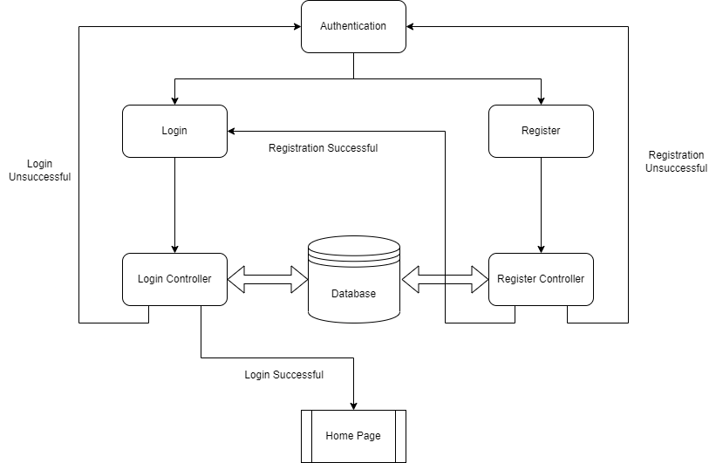

4.1.3 Functional Requirements

* Registeration: Any customer can register to Electronics Mart after filling necessary details in registration form, the email-id should be unique which means there can’t be any existing account with that email id (which is checked at the time of registration). After successful registration user should be redirected to login page, if registration is not successful user should be redirected to User authentication page having both options of login/register.

Input fields & their validation checks in registeration –

* Name
* Email-id – valid email address
* New password –
* atleast 8 letters or number
* atleast one lower case & one uppercase letter
* atleast one number & a special character
* Re-enter password – should be same as new password
* Address – House No., Landmark, City, State, Pin code (number only)
* Interested in categories – user can choose his/her interested categories of products from most popular categories, this is an optional input.

Register might fail in these cases – duplicate email-id, weak password (should pass password validation check), both passwords should match (new pass & re-enter new pass), if any necessary filed is empty last & least possible in case server is down then user will get an error message corresponding to particular error.

After successful registeration user will receive an email containing a unique account activation link, after successful activation of account user can login with his user id & password.

* Login: On login page any user has to enter correct email-id & password, then that email is checked in database if it’s existing then password that user entered is verified with the password in database. If its correct then login is successful & user is redirected to home page of web site where user has multiple functionalities as mentioned in next points.

Login might fail in these cases – If he has entered wrong email-id, wrong password it shows a message saying ‘Invalid Id or Password’ or if user leaves a field, a dialog box shows a warning that a field is empty.

On any new device login, user will get an email regarding security of his account.

If user has enabled Two factor Authentication, then after entering correct email-id & pass then user will be redirected to check OTP page, OTP main will be sent via email on user mail-id, after entering correct otp user can access his account.

User can use forgot password option in case he/she is not able to login due to password issues.

User will have 2 options for recover account –

Recover by email – user will get a recovery email & then user can enter new password with same password validation check as mentioned at the time of registeration.

Recover by old password – if user don’t know current password, then he/she can recover account by previous password & can set new password with same password validation check as mentioned at the time of registeration.

Email regarding successful account recover & new password will be sent to user’s email.

4.1.4 Modules used –

## Browse & Search Products

4.2.1 Description and Priority

This is one of the most important features of the website which enables the customer to browse products in an optimized way, hence having high priority. User can search products by applying many filters and combinations of different filters too.

Actors for this feature –

* All Users
* All Admins

4.2.2 Stimulus/Response Sequences

User Action –

* View all products
* View by major categories (like Electronics – phone, laptop, earphones, etc.)
* View by categories
* View by price range
* View by customer ratings
* View new arrivals
* Search products by name
* View by categories & customer ratings (combination of 2 filters)
* Search products by name in specific category (combination of 2 filters)
* View by rating & categories (combination of 2 filters)
* View by price range & categories (combination of 2 filters)
* View by interest (only for registered users if they have selected any interested category while registration process)
* View specific product with its details.

4.2.3 Functional Requirements

* View all products – users can see all products with mix categories & mix price range
* View by major categories – Products can be sorted via 3 major categories Electronics, Appliances and Sports.

These major categories include these products –

Electronics – Mobile phones, cover & screen protectors, power banks, tablets, headphones & earphones, smart home, laptops, computer accessories, game zone & software, smart watches

Appliances – TV, speakers, camera & DSLR, gaming consoles, AC, heaters, refrigerator, washing machine

Sports – cricket, badminton, cycling, football, gym equipment, sport shoes,

* View by categories – Users can select a specific category from the categories dropdown and view products.
* View by price range – Users can also browse products in between or less than specific price ranges.

Price ranges –

* Under ₹5,000
* ₹5,000 - ₹10,000
* ₹10,000 - ₹20,000
* ₹20,000 - ₹35,000
* ₹35,000 - ₹50,000
* Over ₹50,000
* View by customer ratings – Users can view product based on rating as well.

Ratings - 5, 4.5, 4, 3.5, 3 stars, on selecting any of these rating, the products having more than or equal to that rating will be displayed.

* View new arrivals – Products can also be browsed by new launched/arrived products, basically those products which were last stored in data base.
* Search products by name – A particular product can also be viewed by searching.

If that specific product is not present in the database, then the products related or having similar name will be displayed otherwise there will be no change in products.

* View by categories & customer rating – 2 filter of category & price range are applied together for better product searching.
* Search products by name in specific category – user can search products by name in a specific category.
* View by rating & categories – user can browse products by rating in a category or major category.
* View by price range & categories – user can browse products by price range in major categories (Electronics, appliances, sports).
* View by interest – users can see products by their interested category, this option is only available to registered users. Products will be show on the basis of the interested category they selected at the time of registeration, if they selected none then no change in products.
* View specific product with its details – users can view detailed view of a specific product like -
* Product description
* customer rating & reviews
* can search specific keywords in reviews
* If product’s quantity is less than 10 in stock then it’s also displayed or if it’s out of stock

*Only 9 products will be shown on one screen. for view more user have to go to next page.

4.2.4 Modules used -

## Order Products

4.3.1 Description and Priority

This feature will help logged in users to order any product in stock. This feature is using

an external plugin dependency for payment. After successful payment the product is

ordered. This is one of the key features of shopping website & involves payments due to

which its having high priority & risk.

Actors for this feature –

* Registered User
* Unauthorized Admins
* Authorized Admins

4.3.2 Stimulus/Response Sequences

User Action – Order products, cancel or return product & view previous orders.

Unauthorized Admins – can view all orders

Authorized Admins – can view all orders & update order status

4.3.3 Functional Requirements

* Order Products – User can order any product in stock after successful payment, payment

Implemented by an external plugin.

User will get an email after successful order, which includes order Id.

* Cancel/return Order – user can cancel any order or return it after mentioning a valid.

Reason, in case he has returned the quantity of the product will be restored & updated in

Database. In case of return it should be sent to different department.

* View my orders – a user can also see his previous orders.
* View all orders – all admins can view all orders in optimized way.
* View orders of a single users – enter user id
* View orders by their status – choose an order status
* View order of a particular product – enter product id

*Only 9 orders will be visible on screen at once, for view more user have to go to next page.

* Update Order Status – authorized admins can update order status on completion of different stages of Order.

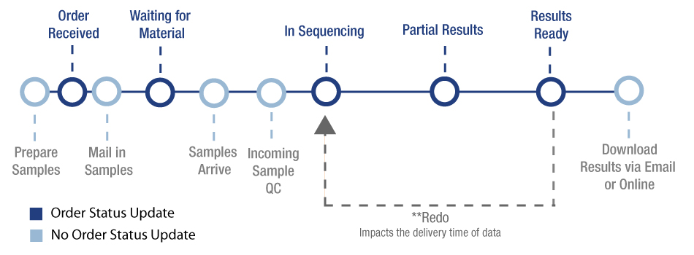

Pending — Customer started the checkout process but did not complete it. Incomplete orders are assigned a "Pending" status and can be found under the More tab in the View Orders screen.

Awaiting Payment — Customer has completed the checkout process, but payment has yet to be confirmed. Authorize only transactions that are not yet captured have this status.

Awaiting Fulfillment — Customer has completed the checkout process and payment has been confirmed.

Awaiting Shipment — Order has been pulled and packaged and is awaiting collection from a shipping provider.

Awaiting Pickup — Order has been packaged and is awaiting customer pickup from a seller-specified location.

Partially Shipped — Only some items in the order have been shipped.

Completed — Order has been shipped/picked up, and receipt is confirmed; client has paid for their digital product, and their file(s) are available for download.

Shipped — Order has been shipped, but receipt has not been confirmed; seller has used the Ship Items action. A listing of all orders with a "Shipped" status can be found under the More tab of the View Orders screen.

Cancelled — User can cancel the order until it’s out for delivery or Seller can cancel an order, due to a stock inconsistency or other reasons. Stock levels will automatically update depending on your Inventory Settings. Cancelling an order will not refund the order. This status is triggered automatically when an order using an authorize-only payment gateway is voided in the control panel before capturing payment.

Returned — Seller has used the Refund action to refund the whole order. A listing of all orders with a "Refunded" status can be found under the More tab of the View Orders screen.

4.3.4 Modules used –

## Manage My Account

4.4.1 Description and Priority

This feature will allow logged in user to view, update, delete account. This includes user data so this is a medium priority feature. Risk regarding data leak or hacking of account should be handled properly for security.

Actors for this feature –

* Registered users
* All admins

4.4.2 Stimulus/Response Sequences

* View my account
* Update account details like –
* Name
* Email id
* Password
* address
* Enable/disable two factor authentication
* Delete account

4.4.3 Functional Requirements

* View my account – user can view his/her account details i.e., name, email-id, address, two factor authentication enabled or disabled.
* Update account details –
* Name – user can change his/her name
* Email id – user can change his/her email id, the new email id should not be registered to any other Electronics Mart account & should be a valid email id.

Email will be sent to the new email id for successful update.

* Password – user has to enter the old password of account in order to change password, the new password validation is same as password validation at the time of registeration.

Email will be sent to the user’s email id about change of password, for security in case the real owner hasn’t updated the password then he/she should recover account as soon as possible.

* Address – user can update address, user can change whole address or any single attribute of address on his/her choice.
* Enable/disable two factor authentication - user can enable of disable this extra account security feature, in this if user logins then a 6-digit OTP will be sent to user’s email id and he/she has to enter that OTP at the time of login.

Email will be sent to user’s email id about enabling or disabling of Two factor authentication.

* Delete account – user can delete his/her account any time they want, at the time of deletion they have to enter correct password of their account for verification.

Email will be sent to the user’s email id about deletion of account.

The user data will be stored in another collection for one year of time span.

4.4.4 Modules used –

## Manage My Cart

4.5.1 Description and Priority

This feature will allow logged in users to add, delete items in cart. Users can directly place order

From my cart if that product is in stock. This is an additional feature so its having low

Priority.

4.5.2 Stimulus/Response Sequences

* Add items to cart
* View my cart
* Update items in cart
* Delete items in cart
* Place order

4.5.3 Functional Requirements

* Add items to cart – user can add any product to cart, initially quantity of product in cart is one.
* View my cart- user can view items added into cart, only 9 items will be shown on a page, for more user has to go to next page.
* Update items – user can increase or decrease quantity of items in cart.
* Delete items in cart –
* Delete one item – user can delete any single item in cart.
* Delete all items – user can delete all items in cart, basically user cart will be emptied.
* Place order –
* Order one item – user can order any single item in cart if that item is in stock.
* Order all items – user can also order all items in cart, but if any item is out of stock, then user has to order other items one by one.

4.5.4 Modules used –

## Manage Products

4.6.1 Description and Priority

This feature will allow logged in admins can add, update, delete product after successful login.

This will provide an Interface to manage products so this is a low priority feature.

Actors for this feature – Authorized admins

4.6.2 Stimulus/Response Sequences

* Add product
* Update product
* Delete product

4.6.3 Functional Requirements

* Add Product – Admins can add a single product at a time.

Input fields & their validation checks –

* Product name
* Product description
* Product Image link – should be a valid image link
* Product price – should be greater than or equal to 0
* Product Quantity – should be greater than or equal to 0
* Product Category
* Product rating

If any of the field is left empty product can’t be added.

* Update Product – Admins can update different attributes of product
* Update product name, price, description, image, category with same validation checks which were used at the time of adding product
* Update product quantity – admins may update quantity more often than product other attributes so update quantity is separated from update of other attributes of products, Admins have to enter the change in product quantity and total quantity of product should be greater than or equal to zero otherwise update will be unsuccessful.
* Delete product – admins can delete any product from database if required.

4.6.4 Modules used –

## Manage Admins

4.7.1 Description and Priority

This feature will allow logged in authorized admins to view admins, authorize/unauthorize admins / delete admins. This feature is having high priority because there's risk of administration power.

Actor for this feature - Authorized admins

4.7.2 Stimulus/Response Sequences

* View admins
* Authorize/Unauthorize admins
* Delete admins

4.7.3 Functional Requirements

* view admins - admin can view all admins, for optimized search admin can search admins by -
* Search by admin id
* Search by email
* Search by name
* View a specific admin - complete details of the admin will be shown

*Only 9 orders will be visible on screen at once, for view more user have to go to next page.

* authorize/unauthorize admins - admins can Authorize or unauthorize other admin as per requirements, option for authorizing or unauthorizing other admins will be provided in detailed view of that admin

Email will be sent to that admin's email id who is authorized or unauthorized.

* delete admin - admin can delete any admin as per requirements, this feature is also provided in detailed view of that admin.

Email will be sent to that admin's email id that his account has been deleted if it looks wrong, he/she can contact the administration.

4.7.4 Modules used –

## Manage Users

4.8.1 Description and Priority

This feature will allow logged in admins to view & search users in an optimized way & delete any user if required. This feature is helping admins to manage users so it a medium priority Feature.

Actors for this feature

* Unauthorized admins - can view & search any user.
* Authorized admins - can view & search any user and delete.

4.8.2 Stimulus/Response Sequences

* + View users
  + Delete users

4.8.3 Functional Requirements

* View users - admins can view or search users in an optimized way
* View all users
* View by name
* View by email id
* View by user id
* View by city
* View by state
* View by pin code

*Only 9 users will be visible on screen at once, for view more user have to go to next page.

* Delete users – only authorized admins can perform this action, if any user is violating any T&C, then his/her account can be deleted.

Email will be sent to user’s email id that his account has been deleted if it looks wrong, he/she can contact the administration.

4.8.4 Modules used -

## Rate & Review products

4.9.1 Description and Priority

This feature will allow logged user to rate & review product so that they can share their experiences of using products with other buyers. This feature helps other users to select better product so, this is feature is having low priority. Any user can only rate or review product when he/she has ordered that product & order status is delivered. Otherwise, the use user can’t rate or review it.

Actor for this feature – Registered user

4.9.2 Stimulus/Response Sequences

* Rate product
* Edit rate
* Review product
* Edit review

4.9.3 Functional Requirements

* Rate Product – User can rate the product once the product is delivered to him/her, rate the product from 1.0 to 5.0 where higher rating means good product.
* Edit rating – User can edit rating of the product he/she has given earlier.
* Review product – user can review the product once the product is delivered to him/her, in review user can share his/her experience in a paragraph with a word limit of 200 words.
* Edit review - User can edit review of the product he/she has given earlier.

4.9.4 Modules used -

## News Letter service

4.10.1 Description and Priority

This feature will allow users to receive news letter emails from website & logged in admins to send newsletter email & view previous newsletter emails. This is an additional feature of website so it’s having low priority.

Actors of this features –

* All users
* All admins

4.10.2 Stimulus/Response Sequences

* Activate newsletter service
* Send newsletter
* View previous newsletters

4.10.3 Functional Requirements

* Activate newsletter Service – any user can activate newsletter service by entering their correct email address in newsletter section of the website, already registered user need not to activate this service because they will receive all newsletter regarding exiting deals & sales.
* Send newsletter – any admin can send newsletter which require a subject & body.
* View newsletter – any admin can view previous newsletter, the subject, body, reciver’s list of the newsletter.

4.10.4 Modules used -

# Other Nonfunctional Requirements

## Performance Requirements

* Use best servers & techniques for data transfer to achieve better performance.
* Use light-weight frontend so that load on end user device is reduced which will give better performance.
* Minimize redirects on your site by frontend AJAX call through which user will get required data without redirecting.
* Use of projection will remove unnecessary data like createdAt, updatedAt, etc. while sending data from backend to frontend which will reduce size of data to be transferred & therefore less loading time hence achieving better performance.
* Use separate database to store images & save the links of images in there corresponding objects which will enhance performance because the images will only load when end user visits the website & will not travel from database to controller & then controller to frontend.
* Use Indexing on product search as it will gives result faster than normal searching.
* Referral traffic knowledge who sends you the most traffic whether its google or your advertisement – can be very valuable in deciding how to best target the majority of your visitors.

## Safety Requirements

* Maintain a backup of data because in case database server gets crashed or something else happen data could be recovered easily.
* Continues Monitoring is required for proper maintenance of website, in case load on website is at its peak the servers should be upgraded by vertical or horizontal scalability as per requirement & we are using a distributed system so it can be achieved easily.

## Security Requirements

* The password must be encrypted while saving in data base.
* The token-id should expire after 2 Hours.
* A middleware should be plugged in before other routes which requires user’s details for authentication which will authenticate users because we hare using HTTPS protocol which is connectionless.
* Another middleware for admins before admins routes (can only view users, orders, products) and another middleware for authorized admins before authorized admin routes (can manage products, users, orders).
* Another middleware if user has activated Two factor authentication which should check whether user has confirmed otp before entering routes which requires user details.

## Software Quality Attributes

* Testing: The software should be tested for both backend, frontend & after integrations another integration testing should be performed.
* Updates: Updates can be easily managed and joined with distributed node JS system.
* Portability: The software should be portable from one device to another i.e., laptop, mobile, etc.
* Availability: The software is 24X7 available except backend servers may get crashed for that we may deploy the website’s backend on different servers after dividing into different nodes so that whole application doesn’t go down only one or two functions may not work in case server gets crash.

## Business Rules

* User will get mailed on every login so if it’s not the user then the user must change the account password for security as soon as possible.
* The admin has rights to delete any users account if the user is violating any rules.
* The admins can update order status and can cancel the order in case the product is unavailable due to some reason.
* If a user cancels any order, then the product quantity, he cancelled should get added to orignal product quantity.

# Modules

6.1 check_email -

Input – everything in request

Description –

Output – everything in response (mention all responses of if else)

# Other Requirements

Electronics Mart shall handle expected & unexpected errors in ways that prevent loss in information & long downtime period.

Appendix A: Glossary

* ODM – object data manipulation which is basically manipulating data when it's transferred from database to application & vice-versa.
* Middleware – It’s a functionality which can be added to the application anywhere it’s required whose task is to perform a specific action.
* Unauthorized Amin – basically these are new admins who have rights to only read database like they can view users, products, orders.
* Authorized Admins – these admins have full rights to do anything, they can register any admin, authorize/unauthorize any admins, manage products, modify order status, manage users, etc.

Appendix B: Analysis Models

Electronics Mart Database

